**USECASE 1**

**Intro to Using Azure Blob Storage SOP**

**Create a Storage Account:**

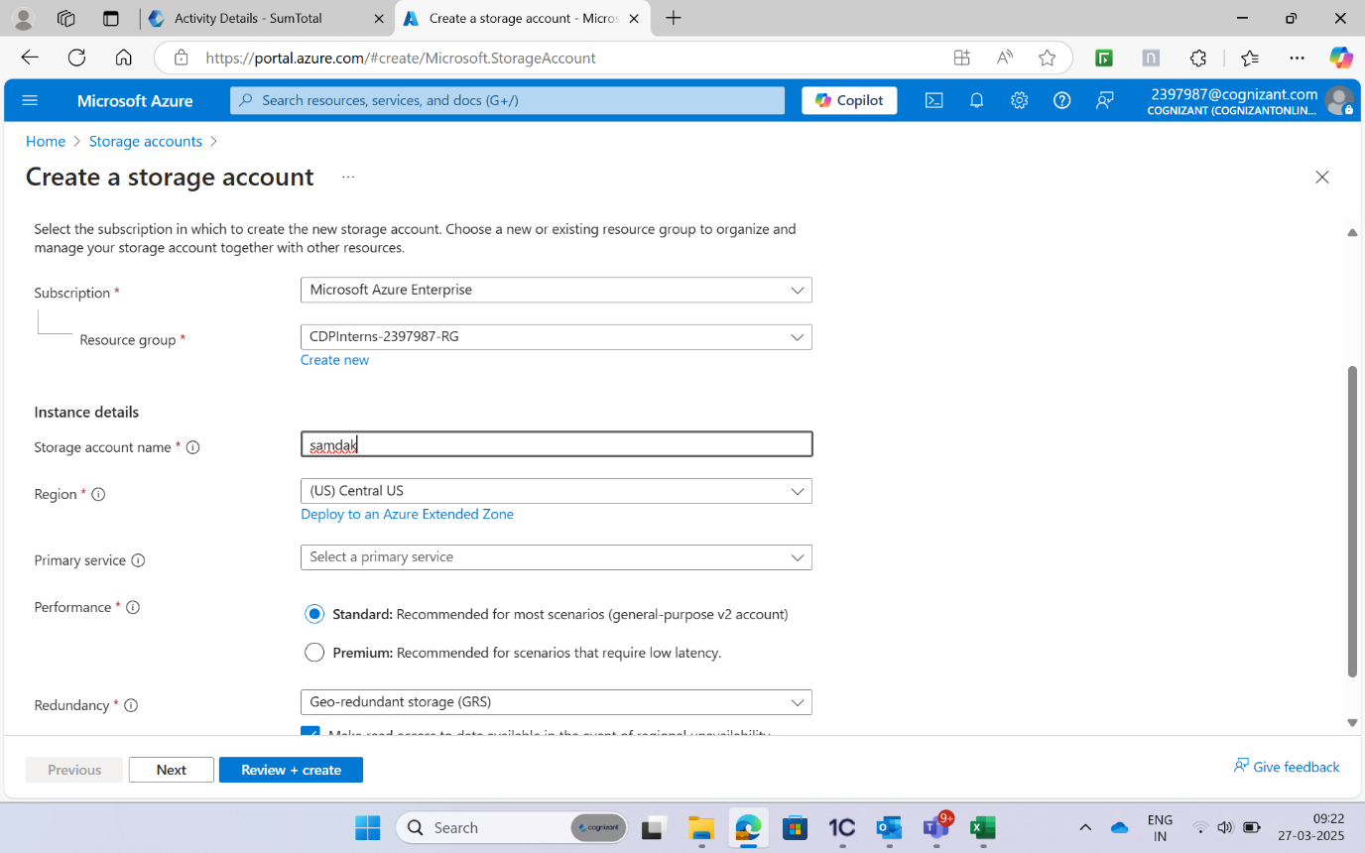

**Deploy the storage account:**

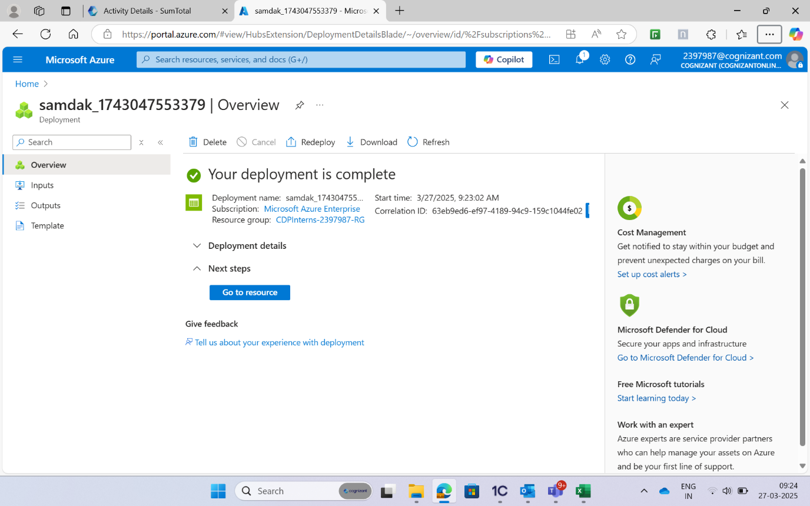

**Open the storage account and go to Blog Service:**

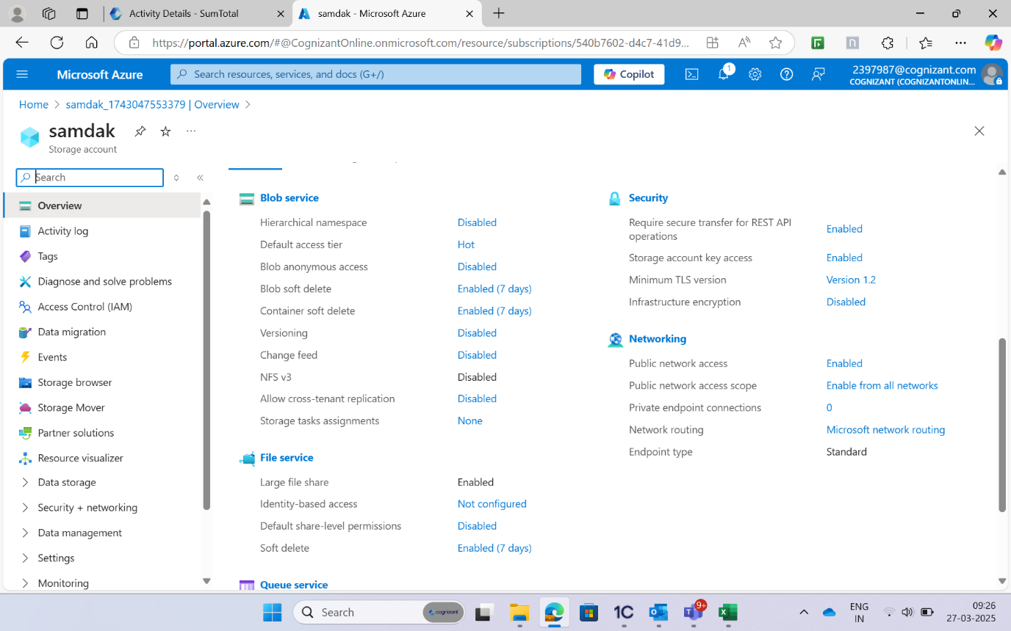

**Create a Blob Container and Upload Files to the Blob Container:**

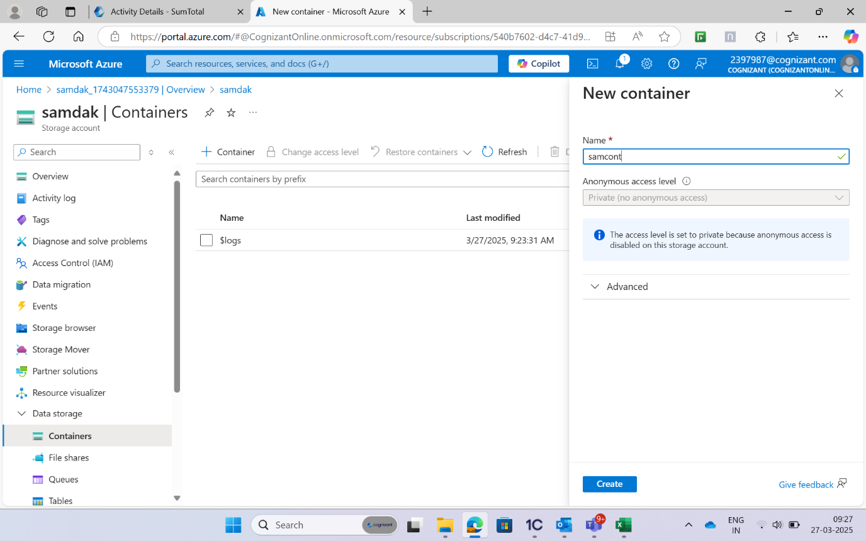

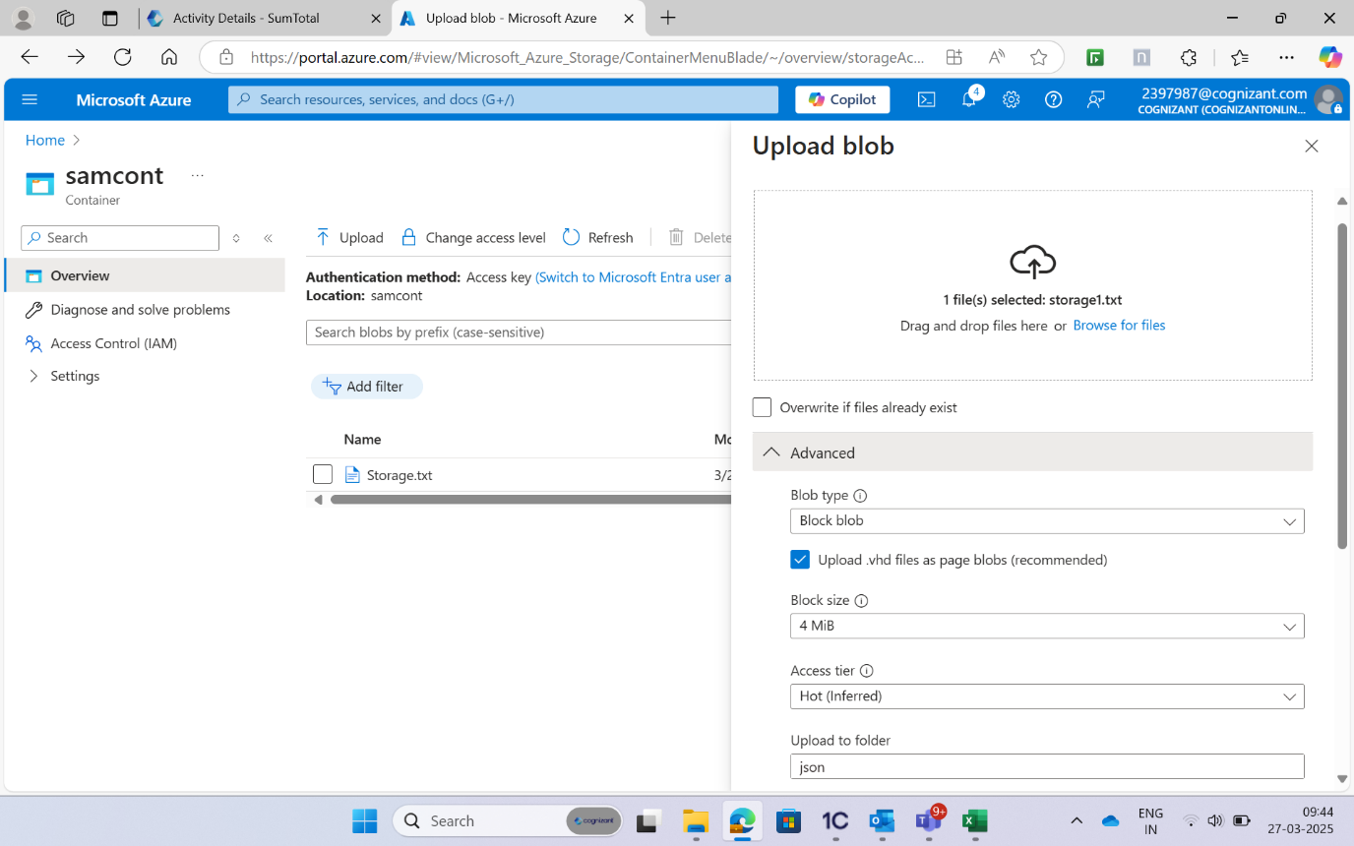

**Under Upload to folder, type json:**

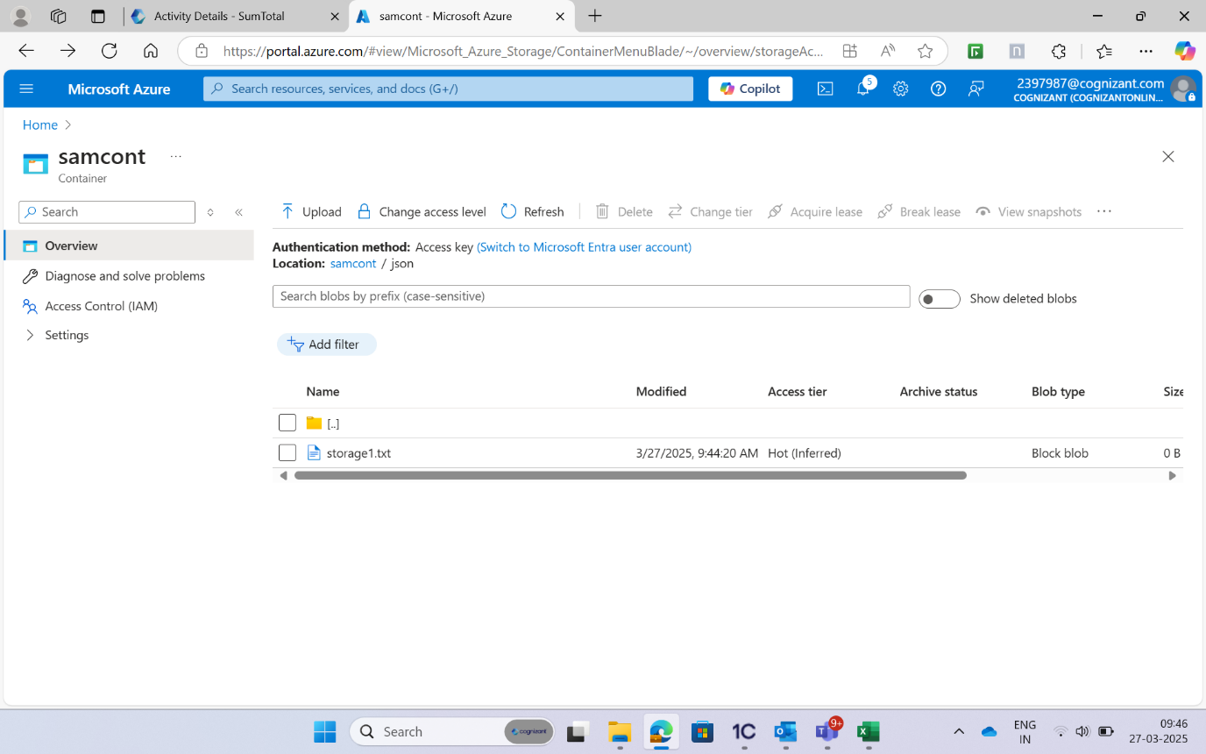

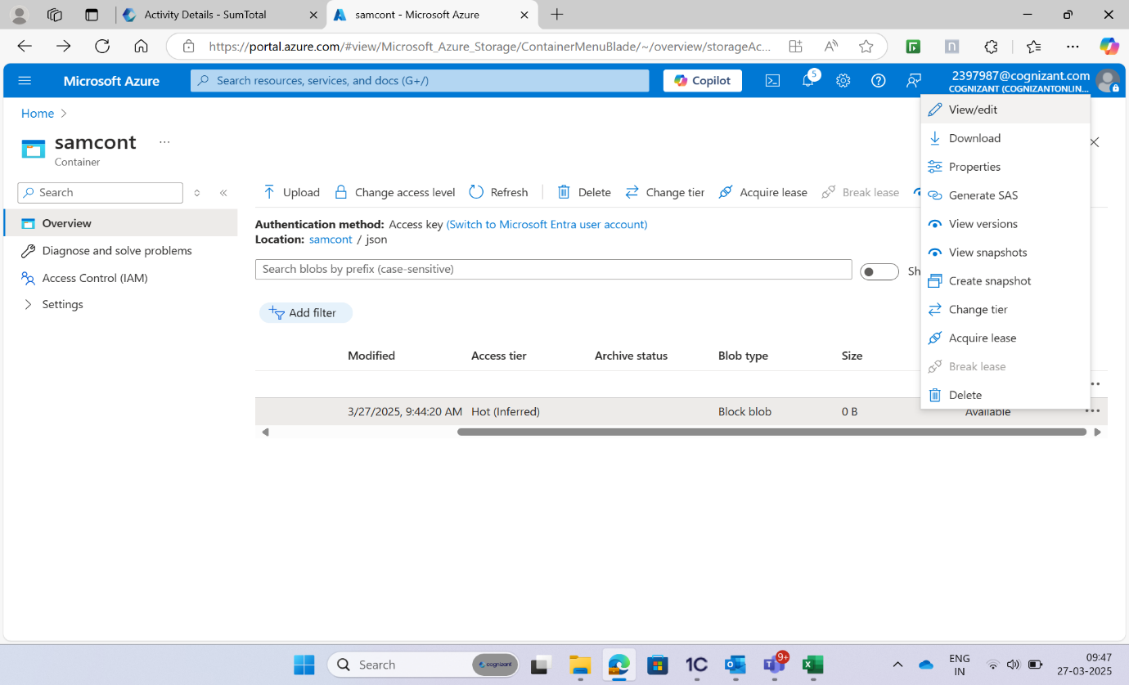

**View Files in the Blob Container:**

